In vitro mRNA-mediated CADM1 expression inhibits proliferation, ‎migration, and invasion in A549 non-small cell lung cancer cells

Seyedeh Fatemeh Mousavi-Ezmareh¹, Mahmoud Aghaei¹, Zarin Sharifnia²,
And Mojtaba Panjehpour^{1*}

Agarose gel electrophoresis to verify single and double enzymatic digestion
Following the extraction of the recombinant plasmid pcDNA3.1(+)-CADM1 from E. coli TOP10 cells using the FavorPrep™ Plasmid Fast Extraction Kit, enzymatic digestion was performed to confirm the successful cloning of the CADM1 gene fragment (1,546 bp) into the multiple cloning site (MCS) of the plasmid between the HindIII and EcoRI restriction sites. To verify both the correct insertion and the efficiency of the restriction enzymes employed, a double digestion of pcDNA3.1(+)-CADM1 was carried out using HindIII and EcoRI simultaneously. In addition, single digestions with each enzyme independently were performed to ensure the accuracy of the cloning procedure. The digestion products were analyzed by 1% agarose gel electrophoresis, and the resulting banding patterns confirmed that the restriction digestions had been performed correctly (Fig. S1). No selective cropping has been applied.

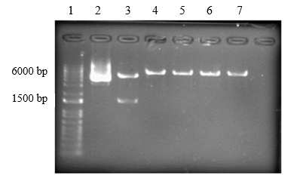
Fig. S1. Agarose gel electrophoresis (1%) showing the pcDNA3.1(+)-CADM1 plasmid before and after restriction enzyme digestion. Lane 1: 1 kb plus DNA ladder (100 bp- 10 kb); Lane 2: undigested pcDNA3.1(+)-CADM1 plasmid; Lane 3: double digestion with EcoRI and HindIII; Lanes 4–5: single digestion with EcoRI; Lanes 6–7: single digestion with HindIII.

Effect of IVT-mRNA CADM1 on NSCLC A549 cell viability
The effect of CADM1 IVT-mRNA on the cell viability of the A549 cell line was evaluated using the MTT assay. Cells were transfected with three concentrations of CADM1 IVT-mRNA (0.1, 0.2, and 0.3 μg) complexed in Lipofectamine MessengerMAX™ at three recommended doses by the instructions (0.15, 0.2, and 0.3 μL) for 24 h and 48 h. To assess the potential cytotoxicity of Lipofectamine MessengerMAX™ itself, parallel groups were treated with the reagent alone at the same concentrations.

Determine the optimal Lipofectamine MessengerMAX™ concentration
Results of IVT-mRNA CADM1 on A549 NSCLC cell viability at 0.15 μL Lipofectamine

Encapsulation of CADM1 IVT-mRNA at 0.15 μL Lipofectamine MessengerMAX™ resulted in a dose-dependent decrease in cell viability of A549 at 24 h and 48 h compared with the nontransfected control. In particular, cell survival decreased significantly at 0.2 μg and 0.3 μg CADM1 IVT-mRNA, reaching 77.8% ± 19.1 and 70.2% ± 5.7 at 24 h, and 68.2% ± 2.2 and 71.6% ± 14.5 at 48 h, respectively. In contrast, treatment with 0.1 μg CADM1 IVT-mRNA yielded survival rates of 82.5% ± 13.5 at 24 h and 81.4% ± 6.3 at 48 h, which were not significantly different from the control. Lipofectamine MessengerMAX™ alone (0.15 μL) did not significantly affect cell proliferation, 99.7% ± 16.6 and 93.2% ± 16.8 at 24 h and 48 h, respectively (Fig. S2 A and B).

A

B
Fig. S2. (A and B) Percentage of cell viability of A549 cells at 24 and 48 h with a concentration of 0.15 μL Lipofectamine MessengerMAX™: Control (nontransfected), Lipofectamine alone (0.15 μL), Lipofectamine (0.15 μL) + CADM1 IVT-mRNA (0.1, 0.2, 0.3 μg). Data are presented as mean ± SD. Statistical analysis was performed using one-way ANOVA. *P < 0.05 and **P < 0.01 indicate significant differences compared to the control group.

Results of IVT-mRNA CADM1 on A549 NSCLC cell viability at 0.3 μL Lipofectamine
CADM1 IVT-mRNA (0.1, 0.2, and 0.3 μg) complexed in 0.3 μL MessengerMAX™ Lipofectamine significantly reduced A549 cell viability in a dose-dependent manner after 24 h, with cell viability rates of 72.2% ± 8.2, 60.8% ± 14.6, and 60.0% ± 5.4, respectively, compared with the nontransfected control. Lipofectamine alone (0.3 μL) caused a significant reduction (75.9 ± 5.05%) in cell viability compared with the nontransfected control (Fig. S3). Due to the high cytotoxicity observed at the 3.0 μL concentration, a reduced concentration of 2.0 μL was selected for subsequent experiments during the main research phase.

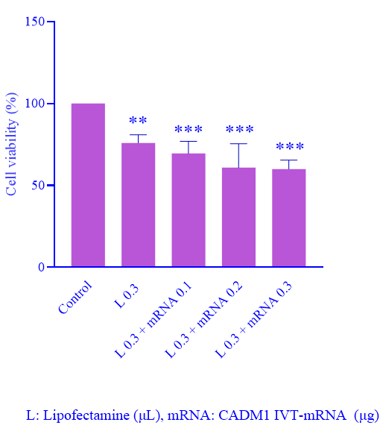
Fig. S3. Effect of IVT-mRNA CADM1 on A549 cell viability after 24 h treatment with 0.3 μL Lipofectamine MessengerMAX™ control (nontransfected), L: Lipofectamine alone (0.3 μL), Lipofectamine (0.3 μL) + CADM1 IVT-mRNA (0.1, 0.2, 0.3 μg). Data are presented as mean ± SD relative to the control. Statistical analysis was performed by one-way ANOVA. **P < 0.01 and ***P < 0.001 indicate significant differences compared to the control group.

Uncropped Western blot images

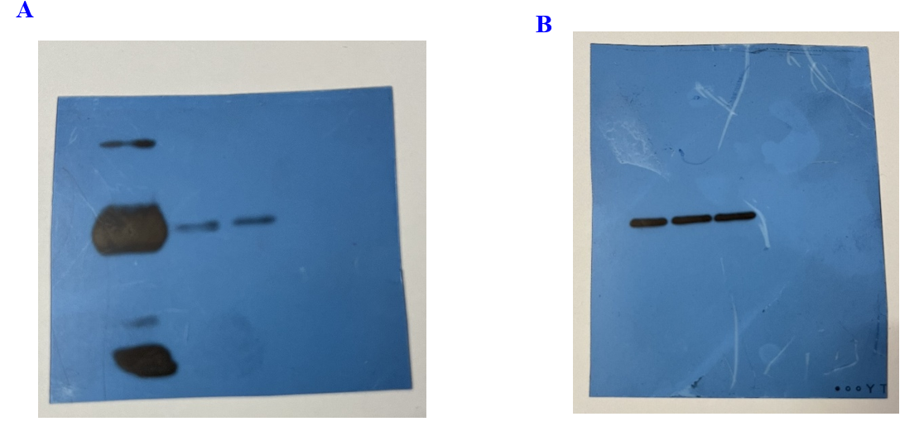
Fig. S4. (A) Uncropped Western blot corresponding to Fig. 4A showing CADM1 protein expression. The blot was detected using film-based chemiluminescence. (B) Uncropped Western blot corresponding to Fig. 4B showing β-actin protein expression. The blot was detected using film-based chemiluminescence.

Optimization experiments to investigate the effect of CADM1 expression on anoikis in NSCLC A549
To evaluate anoikis resistance and cell viability, control (non-transfected) cells were cultured on non-adherent poly (2-hydroxyethyl methacrylate) (poly-HEMA)-coated plates and compared with cells grown under adherent conditions. A total of 8,000 cells were seeded per well in a 96-well plate and maintained on the non-adherent substrate for 8, 16, or 24 hours. Cells were subsequently transferred to adherent wells and incubated for an additional 16 h, after which cell viability was determined using the MTT assay. The proportion of viable cells at 8 h, 16 h, and 24 h was 81.9% ± 8.1, 65.4% ± 3.8, and 21.2% ± 1.01, respectively, indicating a time-dependent reduction in cell survival under anoikis-inducing conditions (Fig. S5). Collectively, these results indicate that a 16-hour incubation period represents an optimal experimental condition for subsequent experimental procedures. It provided a balance between effective induction of anoikis and preservation of sufficient cell viability to enable reliable downstream analyses.

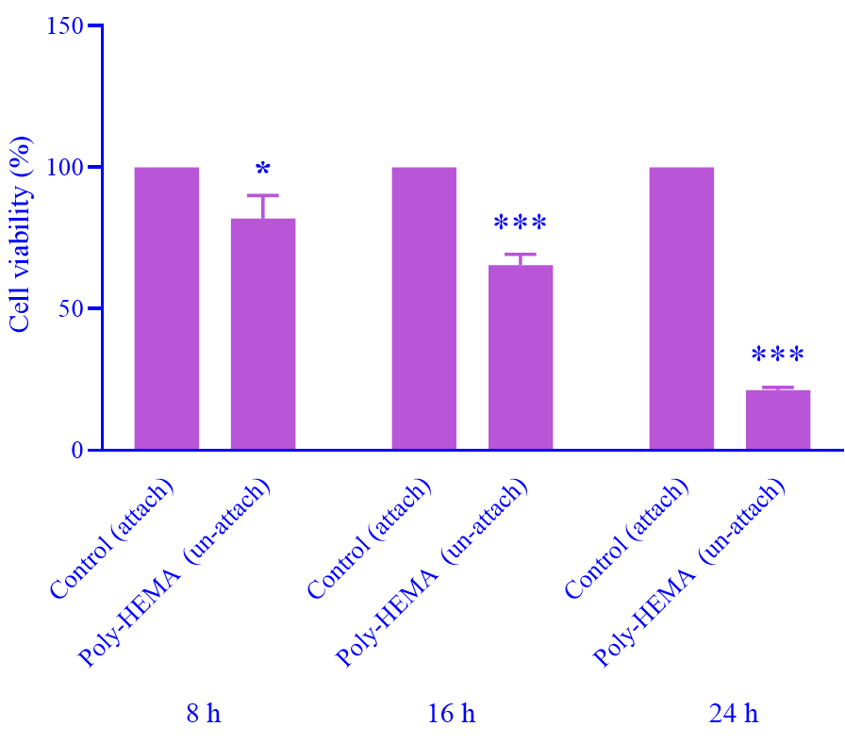
Fig. S5. Evaluation of anoikis resistance in A549 cells. Control cells were cultured under unattached (poly-HEMA-coated) or attached conditions for 8, 16, and 24 h, and anoikis resistance was quantified at the indicated time points using the MTT assay. Data are presented as mean ± SD relative to the control. Statistical analysis was performed by one-way ANOVA. *P < 0.05 and ***P < 0.001 indicate significant differences compared to the control group.

